

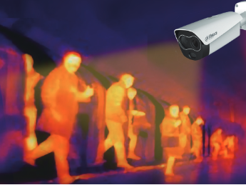

**According to the contagious factor that has been learned in viruses, 1 person has a multiplier effect of 3 transmition.**

**Fever has been detected as one symptom of COVID-19.**

**Protocols for COVID-19 have to be at high levels in critical infrastructures that has been granted exceptions to keep running key important manufacturing operations.**

**Thermal Human Temperature can be measured to robust your COVID-19 Protocol in your facilities and react offering rapid response, but under a safer protocol to avoid your labor force to be infected.**

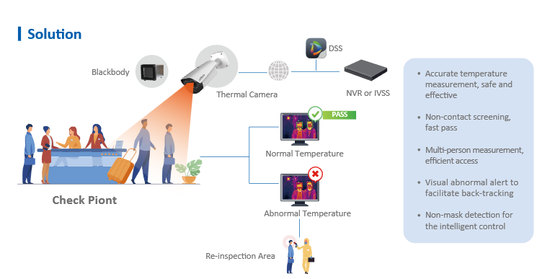

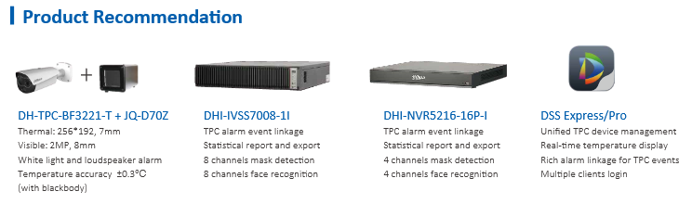

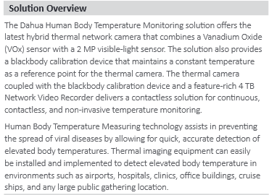

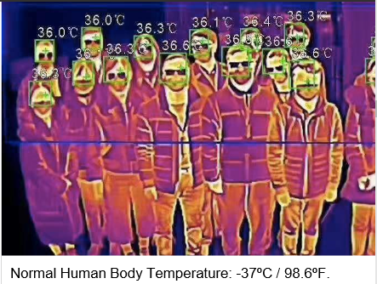

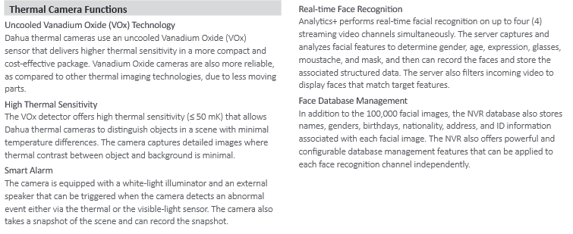

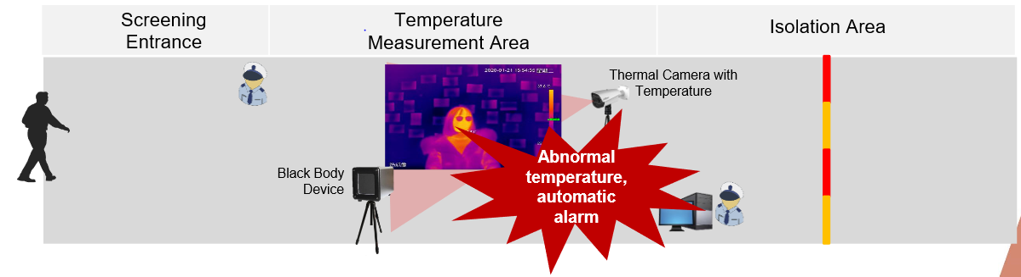

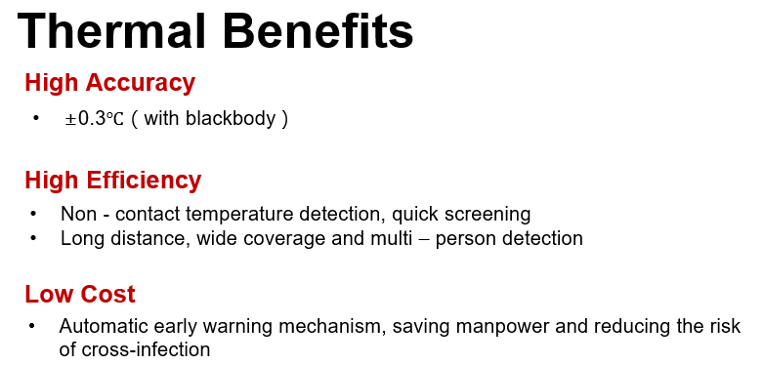

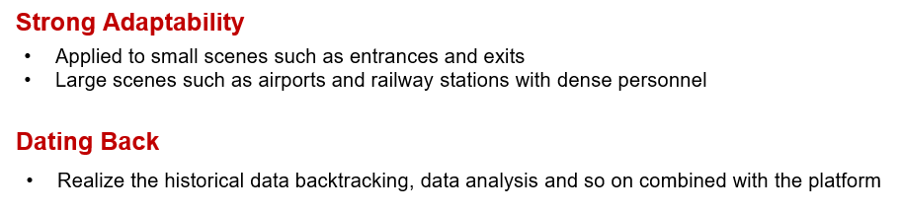

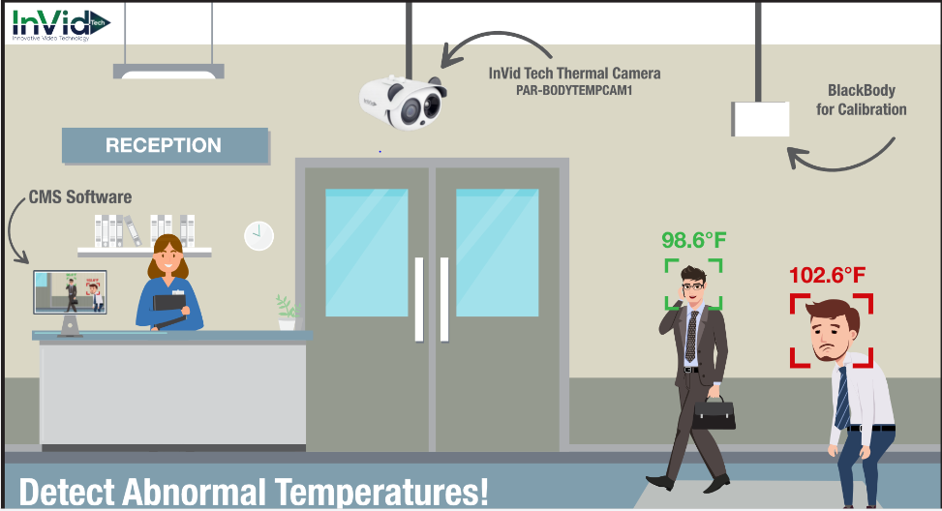

**For further technical questions and assistance of your EHS departments, HR as well as IT concerns, please contact us to offer our support in Puerto Rico and Caribbean region.**

**Email:** [**cmijares@alarmexperts.net**](mailto:cmijares@alarmexperts.net)

**Cesaramijaresg1010@hotmail.com**